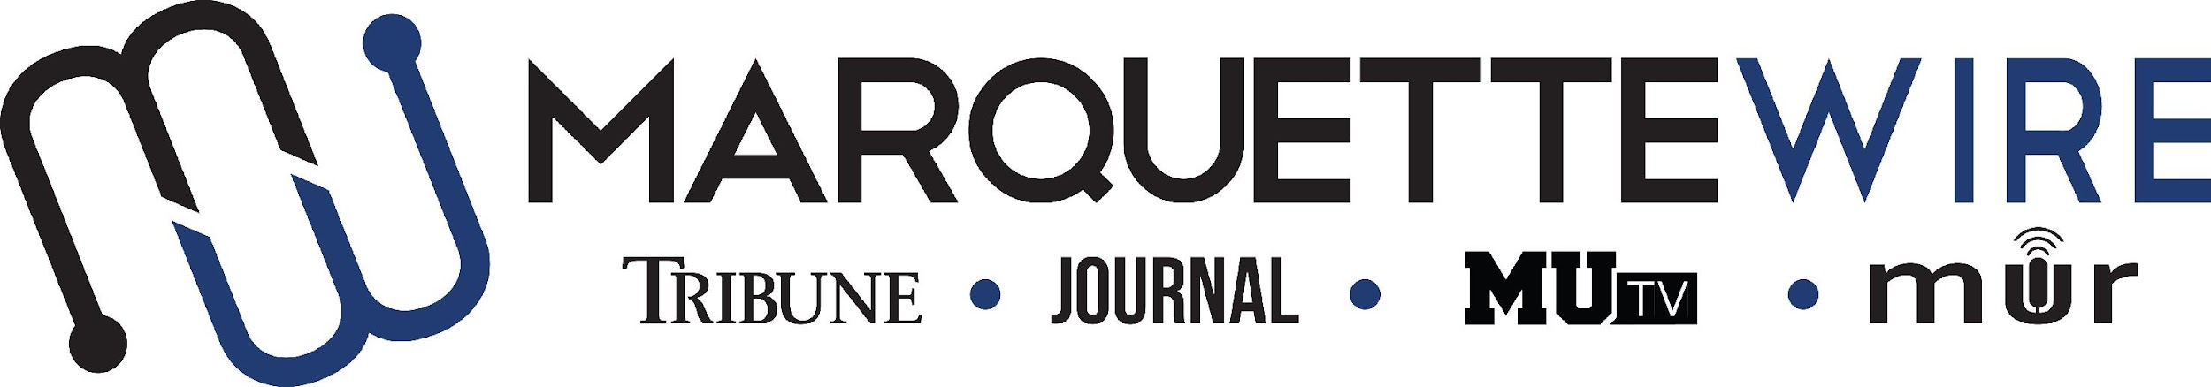

**MARQUETTE WIRE COPY EDITOR APPLICATION**

Academic Year: 2024-2025

Applications should be emailed to Copy Chief Emma Fishback at [emma.fishback@marquette.edu](mailto:emma.fishback@marquette.edu). Once the application is turned in you will receive an email to schedule an interview.

**Applications are due Wednesday, July 31, 2024 at 11:59 p.m. CST. If positions still remain, applications will then be accepted on a rolling basis until all openings are filled.**

Materials to submit include:

- Attached form

- Résumé

- Typed responses to the questions below

- Up to five writing and/or multimedia samples

**JOB DESCRIPTION**

* Edit stories for the Tribune online throughout the weekend and in the newsroom on Mondays
* Edit stories for the Journal during assigned production dates
* Edit online content throughout the week when requested
* Learn AP Style and use these standards when editing stories
* Occasionally edit copy for social media, MUR and MUTV
* Work to improve editing skills each week
* Provide feedback to reporters on stories when requested
* Fact check all assigned stories

**MARQUETTE WIRE COPY EDITOR APPLICATION**

NAME:

PRONOUNS:

ACADEMIC MAJOR(S):

MINOR (IF DECLARED):

OVERALL GPA (Optional): GPA IN MAJOR (Optional):

YEAR IN SCHOOL:

E-MAIL:

PHONE:

CAMPUS ADDRESS:

HOME ADDRESS:

CITY:

STATE/ZIP:

**QUESTIONS**

1. What previous work prepared you for this role, and what do want to accomplish if chosen?
2. How familiar are you with AP Style?
3. How will you stay excited and engaged when editing stories for long periods of time?
4. What makes you a great fit for this role?
5. Would you be willing and available to attend Tribune production on Monday evenings/nights and Journal production on various days during the semester?