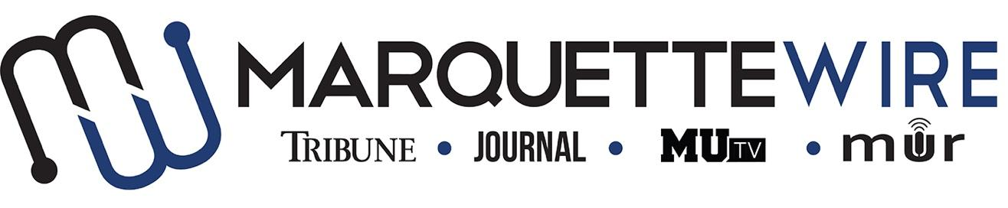

**AUDIO PROGRAMMING DIRECTOR APPLICATION**

Academic Year: 2024-2025

Please email your application materials to MUR General Manager Shannyn Donohue at [shannyn.donohue@marquette.edu](mailto:shannyn.donohue@marquette.edu).

**Applications are due by Wednesday, July 31, 2024 at 11:59 p.m. CST. If the position remains open, applications will be accepted on a rolling basis until it is filled.**

Thank you for your interest in Marquette student media and we wish you the best of luck.

**Job Description**

**Audio Content Director**

* Assisting in editing audio interviews/podcasts for other parts of the Wire staff
* Talking to the different Wire Execs to make sure they have podcasts going out weekly
* Coordinate with Wire Execs to help make sure reporters are adding audio to their stories and creating multimedia pieces.
* Produce a creative audio piece each week that is outside the music realm.
* Help create sweepers for DJ shows, events on campus and other Wire departments to be played by the DJs.
* Assist projects desk in developing a possible long-term audio story.

**AUDIO CONTENT DIRECTOR APPLICATION**

NAME:

PRONOUNS:

POSITION APPLYING FOR:

ACADEMIC MAJOR:

MINOR:

OVERALL GPA (Optional): GPA IN MAJOR (Optional):

YEAR IN SCHOOL

E-MAIL:

PHONE:

CAMPUS ADDRESS:

HOME ADDRESS:

CITY:

STATE/ZIP:

**Application Questions**

1.) How will you effectively coordinate audio content among the various desks in the Marquette Wire?

2.) Pitch a weekly creative audio piece.

3.) How would you work with the projects desk to create long-form podcast content?

4.) What do you think goes into a successful podcast?