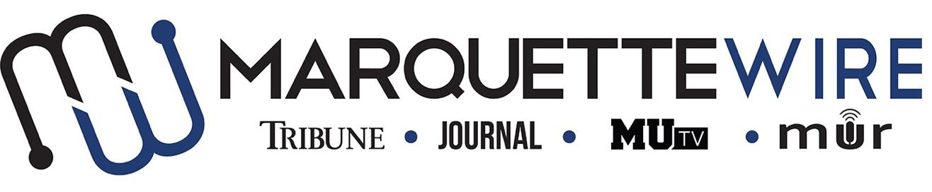

MARQUETTE WIRE ASSISTANT OPINIONS EDITOR APPLICATION

Academic Year: 2024-2025

Applications should be emailed to Executive Opinions Editor Joseph Schamber at joseph.schamber@marquette.edu.

Applications are due by 11:59 p.m. on July 31, 2024. After the deadline passes, if the position has not been filled, applications will be accepted on a rolling basis.

-Once the application is turned in you will receive an email to schedule an interview. If off campus, virtual interviews can be arranged.

Materials to submit include:
- Attached form
- Resume
- Typed responses to the questions below
- At least three writing and/or multimedia samples

Best of luck and thank you for your interest in Marquette Student Media

Assistant Opinions Editor Job Description:

- Responsible for editing budgeted stories assigned for online and print. Edit for content, sentence/paragraph structure and AP style.
- Help reporters with questions that arise when writing their stories and provide feedback once stories are edited.
- Work one newspaper production night a week (Monday nights). At this time, the assistant editor will edit stories to be published the following day and write page headlines, sub-headlines, photo captions. He or she will also set up articles for online viewing at marquettewire.org and schedule social media posts for the new content.
- Attend weekly opinions desk meetings to plan for the next week and generate story ideas.
- Help create video and/or audio content for the Marquette Wire. (If you have never shot or edited audio or video, that is not a problem. We can teach you.)
- Attend weekly All Staff meetings on Tuesdays and Wire training week (typically the week before classes begin).

MARQUETTE WIRE ASSISTANT OPINIONS EDITOR APPLICATION
NAME:
PRONOUNS:
ACADEMIC MAJOR(S):
MINOR (IF DECLARED):
OVERALL GPA (Optional): GPA IN MAJOR (Optional):
YEAR IN SCHOOL:
E-MAIL:
PHONE:
CAMPUS ADDRESS:
HOME ADDRESS:
CITY:
STATE/ZIP:

QUESTIONS
(please answer succinctly)

1) Why are you interested in the position of assistant opinions editor?

2) Describe prior experiences you believe would be beneficial to this position?
3) What is your favorite medium to read? (e.g. magazines, books, newspaper, online, etc.) Why?
4) What unique aspect could you bring to this job?

5) If you are already on the Wire, please provide a critique of the opinions desk. What are some things the desk is doing well? What are things the desk can improve on?

