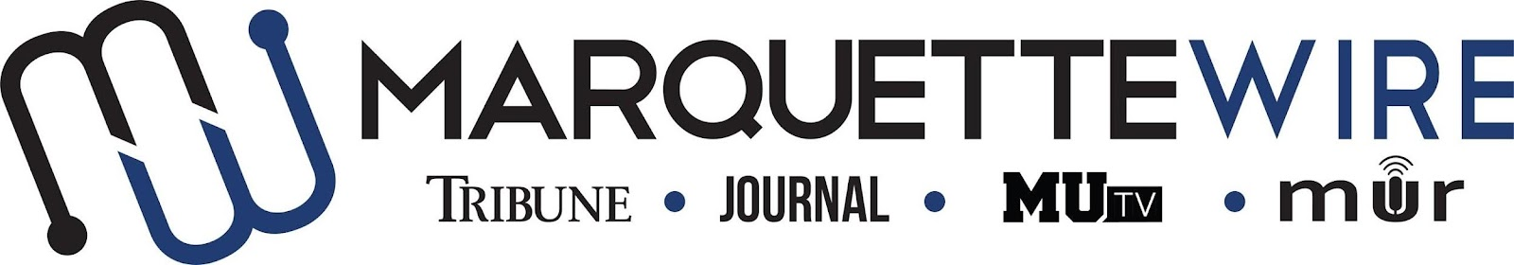

Application for Marquette University Television
Assistant Production Director

This position is to be served for both the fall and spring semesters. Please read the descriptions below for further information on job responsibilities.

The following materials are required for all applicants:

- Completed application
- Resume
- Any additional materials that you think would support your application (Portfolios, websites, videos, etc.)

Please send your completed application materials to Executive Director Hope Moses at hope.moses@marquettte.edu

Applications will be accepted on a rolling basis.

Position Purpose:
The Production Assistant helps plan, coordinate, implement and execute studio and technical aspects of MUTV productions. This position reports to the MUTV Production Director.

Nature and Scope:
The Production Assistant will be taught/expected to staff various technical positions, including serving as director, technical director, and floor director. The assistant will also be taught/expected to operate robotic cameras, studio cameras, tape playback, TelePrompTer, audio, and graphics.

The Production Assistant is required to maintain consistent, productive and constructive communication between the producers of the various content desks and the production department, enabling assistants to execute technical aspects of each program skillfully and professionally. She/he is expected to learn/be knowledgeable about studio equipment and basic troubleshooting.

The Assistant Production director helps train volunteers, assists in the production of live broadcasts and special programs for MUTV and the Marquette Wire website, and is responsible for All technical setup must be completed and operational by show rehearsal time. In addition, she/he is expected to attend Wire all staff meetings and MUTV meetings and take a leading role in student media training week (typically the week before classes begin).

Specific job duties:
- Serves as staff for technical aspects of MUTV studio and live remote productions, which include weekly live news, sports, and entertainment programs.
- Assists by staffing live remote broadcasts for the station and the Marquette Wire website.
- Assists in studio and control room setup for each studio program, including erecting and lighting sets, setting up microphones, IFBs, iPads, and other duties as assigned by show rehearsal time.
- Maintains strong communication and establishes a collaborative work environment with the MUTV news, sports, and entertainment departments.
- Prepares volunteers for their assigned task by assisting in training them to operate the necessary technical equipment.
- Attends MUTV meetings, weekly news desk meetings, Wire all staff meetings and training week (typically the week before classes begin.)

MUTV Production Director Application

Name: ____________________________________________________

Position Sought: ____________________________________________

If you do not receive your first choice, would you be interested in a different position? (Note: Does not have to be in the same department).

Other Position Sought: _______________________________________

Academic Major: ___________________________________________

Minor: ____________________________________________________

Overall GPA (Optional): _____________ GPA in Major (Optional): _______________

Current Year in School: _____________________________________

Email: ___________________________________________________

Cell Phone: _______________________________________________

List of classes you have taken that apply to the position in which you are applying (For example: Digital media 2205): ______________________

__________________________________________________________

Please answer the following questions:

1. What is your experience with television production?

2. How would you improve MUTV and the Wire next year? How would you go about doing this?

3. How will you keep volunteers engaged and excited about MUTV so they keep coming back?

4. How do you handle stressful situations?

