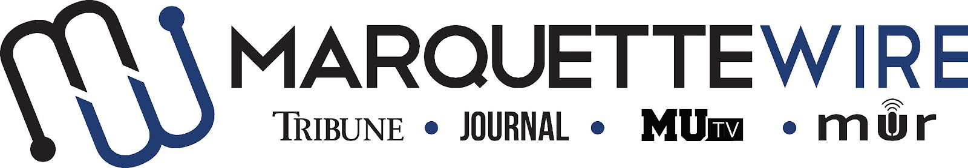

Application for Executive Opinions Editor

Academic Year: 2023-24.
Deadline for all materials is 11:59 p.m. CST on Sunday, April 9, 2023.
Applications should be emailed to incoming executive director Hope Moses at hope.moses@marquette.edu.

You will receive an email shortly after you apply regarding your interview time. If you are studying abroad or will not be on campus for the interview dates, a telephone or Skype interview can be arranged.

Materials to submit include:
- Attached form
- Résumé
- Typed responses to the questions below
- Writing and/or multimedia samples

Best of luck and thank you for your interest in Marquette student media.
Job description for Executive Opinions Editor

Position Purpose:
The Executive Opinions Editor of the Marquette Wire oversees and coordinates all opinions content for the Marquette Wire. This position reports to the Managing Editor of the Tribune for related content, the Managing Editor of the Journal for related content, the General Manager of MUTV for related content and the General Manager of Marquette Radio for related content. The Executive Opinions Editor is expected to work closely with the MUTV General Manager and Marquette Radio General Manager to coordinate multimedia coverage. The Executive Opinions Editor is expected to communicate with the Social Media Editor to coordinate posts on social media accounts. Reporting to the Executive Opinions Editor are the Opinions Designer, Assistant Opinions Editor and Opinions Columnists, whether paid or volunteer.

Nature and Scope:
The Executive Opinions Editor is expected to have extensive, superior knowledge of effective opinions writing. They are responsible for assigning all opinions content, setting deadlines for content, holding weekly desk meetings, recruiting opinions desk staff, interviewing and hiring certain opinions desk staff and training opinions desk staff and volunteers.

The Executive Opinions Editor is expected to create and maintain a professional, upbeat learning environment. They are expected to have superior organizational and communication skills and is responsible for conflict resolution within the opinions desk. The Executive Opinions Editor is expected to maintain a respectable reputation in the community.

The Executive Opinions Editor should coordinate with Assistant Opinions Editor and members of the copy desk to ensure that stories are edited in a timely fashion and in accordance with deadlines.

The Executive Opinions Editor is required to oversee production of the opinions sections of the Marquette Tribune and Marquette Journal. The Executive Opinions Editor is also expected to thoroughly edit all stories in the opinions sections of the Marquette Tribune and Marquette Journal for consistent voice, originality of ideas, accuracy, integrity, writing structure, story structure and copy mistakes.

The Executive Opinions Editor is expected to consistently update the Marquette Wire website with content from all student media platforms.

The Executive Opinions Editor is required to attend Wire all staff meetings and Wire student media training week (typically the week before classes begin).

The Executive Opinions Editor runs weekly editorial board meetings to brainstorm for the weekly Wire editorial that appears in the Marquette Tribune. The Executive Opinions Editor is expected to propose relevant, viable ideas at this meeting. The Executive Opinions Editor is expected to take a lead role in writing the editorial each week.

Specific job duties:

- Oversees all opinion and editorial content for the Marquette Wire.

- Trains and oversees all members of the opinions desk, which includes the Assistant Opinions Editor, Opinions Columnists and the Opinions Designer.

- Generates multimedia story ideas with MUTV and Marquette Radio staff members.

- Curates multimedia story ideas for a weekly budget for the opinions desk, which should include coverage for the Marquette Tribune, MUTV, Marquette Radio, as well as the Marquette Journal around production time.

- Edits online and print stories for content and grammar.

- Helps the Opinions Designer come up with ideas for designs for the Tribune and Journal.

- Runs weekly desk meetings and assign stories to columnists.

- Attends weekly all staff meetings.

- Attends weekly Late Night newspaper production sessions, as well as designated Journal production days.

- Recruits, interviews and hires the following desk staff: Assistant Opinions Editor and Opinions Columnists.

- Runs weekly editorial board meeting to brainstorm for the weekly Wire editorial that appears in the Marquette Tribune.

Information for Executive Position, Marquette Wire

NAME: ________________________________________________

ACADEMIC MAJOR(S):______________________________________

MINOR(S): _________________________________________________

OVERALL GPA (Optional) : _________

YEAR IN SCHOOL: ________________________________________

EMAIL: _________________________________________________

PHONE: _________________________________________________

HOME ADDRESS: ________________________________________

CITY:____________________________________________________

STATE/ZIP: ______________________________________________
Application Questions for Executive Opinions Editor:

1) What work within student media has prepared you for this leadership role, and what do want to accomplish if chosen?

2) Please provide a critique of the desk you are applying for and assess the current structure of the desk.

3) Explain your conflict-resolution style and how you would handle disputes at all levels of student media.

4) What about your desk would you like to change, or improve?

5) What makes you the best candidate for this job?

