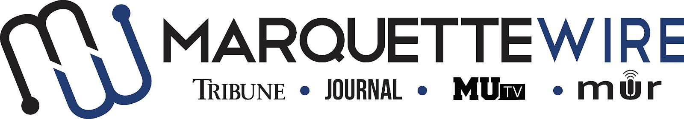

Application for Executive News Editor

Academic Year: 2023-24.
Deadline for all materials is 11:59 p.m. CST on Sunday, April 9, 2023.
Applications should be emailed to incoming executive director Hope Moses at hope.moses@marquette.edu.

You will receive an email shortly after you apply regarding your interview time. If you are studying abroad or will not be on campus for the interview dates, a telephone or Skype interview can be arranged.

Materials to submit include:
- Attached form
- Résumé
- Typed responses to the questions below
- Writing and/or multimedia samples

Best of luck and thank you for your interest in Marquette student media.
Job description for Executive News Editor

Position Purpose:
The Executive News Editor of the Marquette Wire oversees and coordinates all news content for the Marquette Wire, including coordination of breaking news coverage. This position reports to the Managing Editor of the Tribune for related content, the Managing Editor of the Journal for related content, the General Manager of MUTV for related content and the General Manager of Marquette Radio for related content. Reporting to the Executive News Editor are the Design Chief, Assistant News Editors, News Reporters, MUTV Executive News Producer, Assistant MUTV News Producers and News Audio Producer, whether paid or volunteer positions.

Nature and Scope:
The Executive News Editor is expected to be knowledgeable about issues and events important to Marquette and higher education, and have excellent news reporting, editing, organizational and communication skills. She/he is expected to have superior organizational and communication skills, and is responsible for conflict resolution within the news desk.

The Executive News Editor is the supervisor of all members of the news desk. She/he budgets and assigns all content for the news desk and is expected to work closely with the MUTV Executive News Producer, Assistant MUTV News Producers and News Audio Producer to coordinate multimedia coverage.

The Executive News Editor is expected to create and maintain a professional, upbeat learning environment, providing members of the news desk with insight and resources, all while maintaining a professional reputation in the community.

The Executive News Editor is responsible for assigning all news content, setting deadlines for content, holding weekly desk meetings, recruiting news desk staff, interviewing and hiring certain news desk staff and training news desk staff.

The Executive News Editor will ensure that there is consistent, productive and constructive communication between all news desk staff members. This person will coordinate with Assistant News Editors and the copy desk to ensure that stories are edited in accordance with deadlines. This person will communicate with the Social Media Editor to coordinate posts on social media accounts.

The Executive News Editor oversees production of the news sections of the Marquette Tribune and Marquette Journal, editing for accuracy, integrity, writing structure, story structure and grammar. The Executive News Editor is expected to consistently update the Marquette Wire website with breaking news stories and content from all student media platforms. The Executive News Editor should attend MUTV’s weekly production of Marquette Now, and is required to attend Wire all staff meetings, MUTV news meetings and Wire student media training week (typically the week before classes begin).

Specific job duties:

- Oversees all news content for the Marquette Wire.

- Trains and oversees all members of the news desk, which includes Assistant News Editors, News Reporters, Design Chief, MUTV Executive News Producer, Assistant MUTV News Producers and News Audio Producer, whether paid or volunteer positions.

- Works closely with the MUTV Executive News Producer, Assistant MUTV News Producers and News Audio Producer to coordinate multimedia coverage.

- Curates multimedia story ideas for a weekly budget for the news desk, which should include coverage for the Marquette Tribune, MUTV, Marquette Radio, as well as the Marquette Journal around production time.

- Edits online and print stories for content and grammar.

- Runs weekly desk meetings and assign stories to reporters.

- Recruits, interviews and hires the following desk staff: Assistant News Editors and News Reporters.

- Helps the Design Chief come up with ideas for designs for the Tribune and Journal.

- Attends weekly all staff meetings.

- Attends weekly Late Night newspaper production sessions, as well as designated Journal production days.

- Participates in weekly editorial board meeting to brainstorm for the weekly Wire editorial that appears in the Marquette Tribune.

Information for Executive Position, Marquette Wire

NAME: ________________________________________________

ACADEMIC MAJOR(S):______________________________________

MINOR(S): _________________________________________________

OVERALL GPA (Optional): _______________

YEAR IN SCHOOL: ________________________________________

EMAIL: _________________________________________________

PHONE: _________________________________________________

HOME ADDRESS: ________________________________________

CITY:____________________________________________________

STATE/ZIP: ______________________________________________

Application Questions for Executive News Editor:

1) What work within student media has prepared you for this leadership role, and what do want to accomplish if chosen?

2) Please provide a critique of the desk you are applying for and assess the current structure of the desk.

3) Explain your conflict-resolution style and how you would handle disputes at all levels of student media.

4) What about your desk would you like to change, or improve?

5) What makes you the best candidate for this job?

