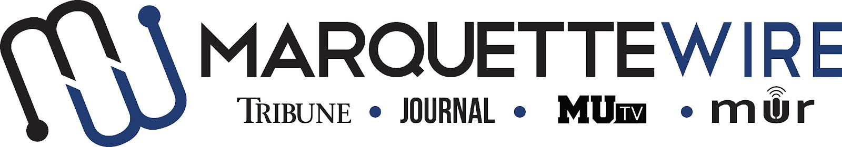

Application for Copy Chief

Academic Year: 2023-24.
Deadline for all materials is 11:59 p.m. CST on Sunday, April 9, 2023.
Applications should be emailed to incoming executive director Hope Moses at hope.moses@marquette.edu.

You will receive an email shortly after you apply regarding your interview time. If you are studying abroad or will not be on campus for the interview dates, a telephone or Teams interview can be arranged.

Materials to submit include:
- Attached form
- Résumé
- Typed responses to the questions below
- Writing and/or multimedia samples

Best of luck and thank you for your interest in Marquette student media.
Job description for Copy Chief

Position Purpose:
The Copy Chief of the Marquette Wire oversees all copy for the Marquette Wire. This position reports to the Managing Editor of the Tribune for related content, the Managing Editor of the Journal for related content, the General Manager of MUTV for related content and the General Manager of Marquette Radio for related content. The Copy Chief is expected to provide guidance and feedback to copy editors on AP Style, English grammar and writing mechanics. The Copy Chief should be knowledgeable in the aforementioned areas. The Copy Chief is expected to communicate with the Social Media Editor to edit posts on social media accounts, as well as the email newsletter, when requested. Reporting to the Copy Chief are the Copy Editors.

Nature and Scope:
The Copy Chief is expected to have extensive, superior knowledge of AP Style, English grammar and writing mechanics. They are responsible for holding weekly desk meetings, recruiting copy desk staff, interviewing and hiring copy desk staff and training copy desk staff and volunteers.

The Copy Chief is expected to create and maintain a professional, upbeat learning environment. They are expected to have superior organizational and communication skills and is responsible for conflict resolution within the copy desk.

The Copy Chief is required to meet and enforce editing deadlines. The Copy Chief is expected to ensure that online stories are edited by the copy desk in a timely fashion throughout the week. The Copy Chief is expected to ensure that copy desk staff members are available to edit breaking news stories on short notice. The Copy Chief is required to attend Wire all staff meetings and Wire student media training week (typically the week before classes begin).

The Copy Chief should be detail-oriented and precise in order to ensure clean copy. The Copy Chief is expected to maintain a professional reputation in the community.

Specific job duties:

- Oversees, leads and motivates the copy desk staff in editing stories and copy for the Tribune, Journal, MUTV and Marquette Radio.

- Manages other copy editors' schedules to ensure availability for editing throughout the week and during Tribune and Journal production days.

- Creates weekly schedules for copy editors.

- Creates efficient workflow system for daily content.

- Edits articles daily for marquettwire.org, at weekly Late Night production sessions for the Marquette Tribune, and at designated production times for the Marquette Journal.

- Edits copy for MUTV and Marquette Radio when requested.

- Edits copy for social media when requested.

- Participates in weekly editorial board meeting to brainstorm for the weekly Wire editorial that appears in the Marquette Tribune.

- Runs weekly desk meetings with copy desk staff to critique and improve copy.

- Attends weekly all staff meetings.

- Recruits, interviews and hires copy editors for the Marquette Wire.

- The Copy Chief is required to attend student media training week (typically the week before classes begin).

- Extensive knowledge of AP Style, English grammar and writing mechanics is required.

Information for Executive Position, Marquette Wire

NAME: ________________________________________________

ACADEMIC MAJOR(S):______________________________________

MINOR(S): _________________________________________________

OVERALL GPA (Optional): _______________

YEAR IN SCHOOL: ________________________________________

EMAIL: _________________________________________________

PHONE: _________________________________________________

HOME ADDRESS: ________________________________________

CITY:____________________________________________________

STATE/ZIP: ______________________________________________

Application Questions for Executive Opinions Editor:

1) What work within student media has prepared you for this leadership role, and what do you want to accomplish if chosen?

2) Please explain a time where you displayed effective leadership abilities.

3) Explain your conflict-resolution style and how you would handle disputes at all levels of student media.

4) What makes you the best candidate for this job?

