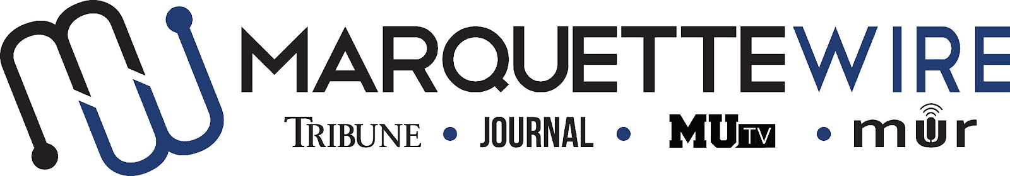

MARQUETTE WIRE COPY EDITOR APPLICATION

Academic Year: 2022-’23

-Applications should be emailed to Copy Chief Emily Reinhardt at emily.reinhardt@marquette.edu. Once the application is turned in you will receive an email to schedule an interview.

Applications will be accepted on a rolling basis.

Materials to submit include:
- Attached form
- Résumé
- Typed responses to the questions below
- Up to five writing and/or multimedia samples

COPY EDITOR JOB DESCRIPTION
- Edit stories for the Tribune online on Sundays and in the newsroom on Mondays
- Edit stories for the Journal during assigned production dates
- Edit online content throughout the week when requested
- Learn AP Style and use these standards when editing stories
- Occasionally edit copy for social media, MUR and MUTV
- Work to improve editing skills each week
- Provide feedback to reporters on stories when requested
NAME:
ACADEMIC MAJOR(S):

MINOR (IF DECLARED):

OVERALL GPA (Optional):

GPA IN MAJOR (Optional):

YEAR IN SCHOOL:

E-MAIL:

PHONE:

CAMPUS ADDRESS:

CITY:

STATE/ZIP:

APPLICATION QUESTIONS

- What previous work prepared you for this role, and what do want to accomplish if chosen?

- How familiar are you with AP Style?

- How will you stay excited and engaged when editing stories for long periods of time?

- What makes you a great fit for this role?

- Would you be willing and available to attend Tribune production on Monday evenings/nights and Journal production on various days during the semester?

