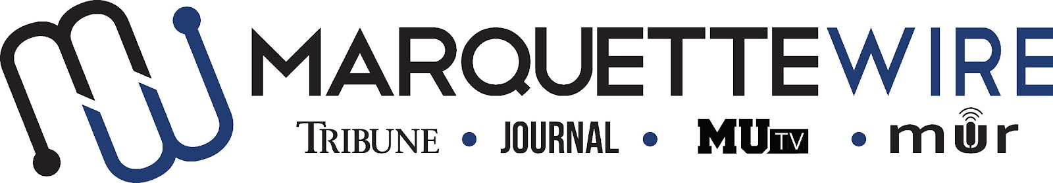

MARQUETTE WIRE PHOTOGRAPHER APPLICATION

-Academic Year: 2022-’23
-Applications should be emailed to Executive Photo Editor Izzy Bonebrake at isabel.bonebrake@marquette.edu. Once the application is turned in you will receive an email to schedule an interview.

The application deadline is Monday, July 11, at Noon CST. If openings remain after this date, application materials will be accepted on a rolling basis.

Materials to submit include:
- Attached form
- Résumé
- Typed responses to the questions below
- Up to five photography examples

PHOTOGRAPHER JOB DESCRIPTION

- Take assigned still photos across all desks of the Marquette Wire, including news, sports, A&E and opinions
- Edit all photos in Photoshop or other editing program to produce high-quality images
- Upload all photos to appropriate folders in Google Drive for Wire photo desk
- Meet weekly and semesterly deadlines for photos
- Communicate effectively with reporters to get photos for stories
- Reach out to sources for stories, or accompany reporters to events/interviews, to take assigned photos
- Work with executive editors and managers on vision for assigned photos
- Become familiar with Adobe Photoshop, Adobe Illustrator and potentially other Adobe design programs
- Become familiar with still photography equipment, particularly DSLR cameras
- Attend weekly desk meetings
- Attend weekly Wire all staff meeting
- Improve photographic skills each week

NAME:

ACADEMIC MAJOR(S):

MINOR (IF DECLARED):

OVERALL GPA (Optional):

GPA IN MAJOR (Optional):

YEAR IN SCHOOL:

E-MAIL:

PHONE:

CAMPUS ADDRESS:

CITY:

STATE/ZIP:

APPLICATION QUESTIONS

- What do you know about journalistic photography?

- How would you describe your photographic style, and what do you think goes into a good photo?

- What do you enjoy taking photos of the most?

- Visit our website, marquettewire.org and critique the current photographic content. What are things you like? Where can photographic content grow?

