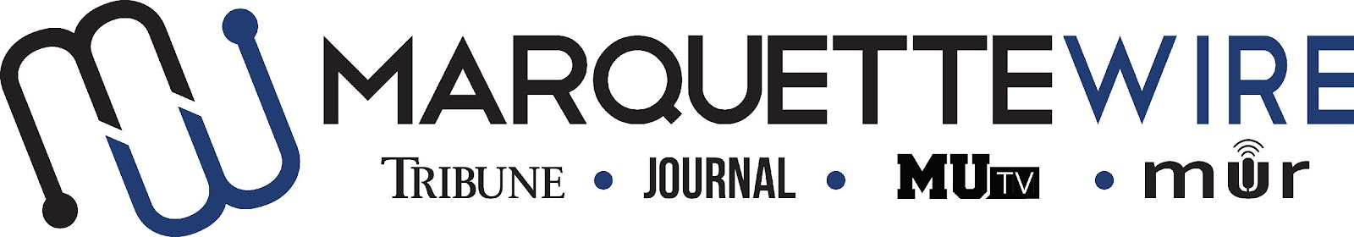

MARQUETTE WIRE COPY EDITOR APPLICATION

-Academic Year: 2022-’23
-Applications should be emailed to Copy Chief Emily Reinhardt at emily.reinhardt@marquette.edu. Once the application is turned in you will receive an email to schedule an interview.

The application deadline is Monday, July 11, at Noon CST. If openings remain after this date, application materials will be accepted on a rolling basis.

Materials to submit include:
- Attached form
- Résumé
- Typed responses to the questions below
- Up to five writing and/or multimedia samples

COPY EDITOR JOB DESCRIPTION

- Edit stories for the Tribune online on Sundays and in the newsroom on Mondays
- Edit stories for the Journal during assigned production dates
- Edit online content throughout the week when requested
- Learn AP Style and use these standards when editing stories
- Occasionally edit copy for social media, MUR and MUTV
- Work to improve editing skills each week
- Provide feedback to reporters on stories when requested

NAME:

ACADEMIC MAJOR(S):

MINOR (IF DECLARED):

OVERALL GPA (Optional):

GPA IN MAJOR (Optional):

YEAR IN SCHOOL:

E-MAIL:

PHONE:

CAMPUS ADDRESS:

CITY:

STATE/ZIP:

APPLICATION QUESTIONS

- What previous work prepared you for this role, and what do you want to accomplish if chosen?

- How familiar are you with AP Style?

- How will you stay excited and engaged when editing stories for long periods of time?

- Would you be willing and available to attend Tribune production on Monday evenings/nights and Journal production on various days during the semester?

