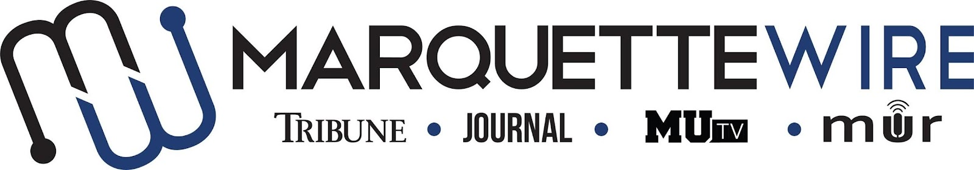

Application for Marquette University Radio
Audio Sports Producer

This position is to be served for both the fall and spring semesters. Please read the descriptions below for further information on job responsibilities.

The following materials are required for all applicants:

- Completed application
- Resume
- Any additional materials that you think would support your application (Portfolios, websites, videos, etc.)

Please send your completed application materials to MUR General Manager Emily Bittman at emily.bittman@marquette.edu.

The deadline for all materials to be submitted by is Sunday, May 22th at 11:59 p.m. CST.

Position Purpose:
The MUR Audio Sports Producer plans, coordinates and creates the weekly MUR sportscast. The Audio Sports Producer also works closely with sports reporters to create podcasts and other audio content for the sports section of the Marquette Wire. This person is expected to provide training and guidance to sports reporters who wish to become more familiar with audio storytelling. This person also works closely with the Executive Sports Editor to plan and help execute MUR live broadcasts when needed.

This position reports to the Marquette Wire Executive Sports Editor as well as the MUR General Manager.

Nature and Scope:
The MUR Audio Sports Producer works closely with the Marquette Wire Executive Sports Editor to plan and execute weekly audio sports content for the Marquette Wire based off the budget created by the Wire Executive Sports Editor. She/he is required to maintain strong communication with sports reporters and the Executive Sports Editor, and is expected to create and maintain a professional, upbeat learning environment. The MUR Audio Sports Producer is expected to plan and execute a weekly MUR radio sportscast.

The MUR Audio Sports Producer must be proficient in Adobe Audition. It is preferable that the MUR Audio Sports Producer is familiar with the MUR radio studio equipment, as well as other recording equipment.

The MUR Audio Sports Producer is expected to attend Wire all staff meetings, designated MUR meetings, and weekly sports desk budget meetings, as well as attend student media training week (typically the week before classes begin).

MUR Audio Sports Producer Application

Name: ____________________________________________________

Position Sought: MUR Audio Sports Producer

Academic Major: ___________________________________________

Minor: ____________________________________________________

Overall GPA (Optional): _____________ GPA in Major (Optional): _______________

Current Year in School: _____________________________________

Email: ___________________________________________________

Cell Phone: _______________________________________________

List classes you have taken that apply to the position in which you are applying ______________________________________________________________________

Please answer the following questions:

1. What goes into a successful audio sports story?

2. Pitch an audio sports story.

3. What vision do you have for the weekly MUR sportscast?

4. How would you help train other staff members who are interested in learning about audio storytelling?

