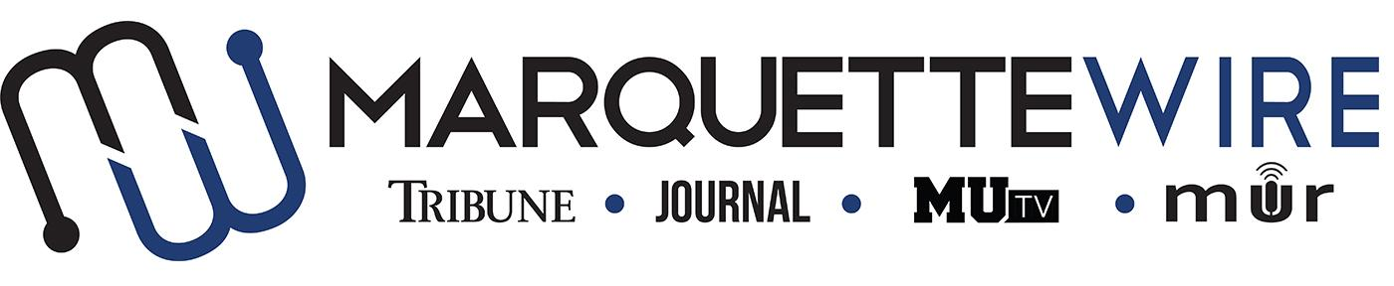
MARQUETTE WIRE ASSISTANT SOCIAL MEDIA PRODUCER APPLICATION

Academic Year: 2022-’23
Applications should be emailed to Executive Social Media Producer Nancy Flaherty at nancy.flaherty@marquette.edu . Once the application is submitted, you will receive an email to schedule an interview. The application deadline is accepted on a rolling basis until the position is filled.

Materials to submit include:
Attached form
Resume
Typed responses to the questions below
3-5 samples of social media experience

Job requirements
- Use Hootsuite to assist in making daily posts across all social platforms
- Assist in creating weekly schedule of posts
- Edit all posts with Executive Social Media Producer
- Communicate with managers and assistants to cover all parts of the Wire
- Attend a weekly 30-minute meeting with Executive Social Media Producer and Executive Director to evaluate posts and analytics
- Attend weekly All Staff meeting on Tuesday nights
- Attend Late Night on Monday nights for approximately 30 minutes with Executive Social Media Producer to plan posts for the week
- Attend other short meetings that might be scheduled with managers
- Attend Wire events or coordinate with those who are there to either live tweet or get photos to cover
- Communicate quickly and efficiently with other staff in breaking news situations
- Strategize with Executive Social Media Producer about how to increase engagement (the executive will track analytics)

Skills needed
Helpful if you have some background with most of these, but all can be taught quickly
- AP Style
- Thorough knowledge of all social media platforms (i.e. beyond just making simple posts; how to embed different links and media, how to create events, polls, etc.)
- Concise, witty writing ability
- Exceptional organization skills
- Good iPhone photography skills

Availability
This is an around-the-clock job – you will need to put in work daily.
Typical time commitment needed:
- Tuesdays: Around 2 hours in addition to meetings
- Wednesday, Thursday, Friday: 30 mins – 1 hr
- Saturday, Sunday, Monday: 10 – 30 mins
Must be available Tuesday mornings to begin scheduling posts for the week. Good if available Tuesday afternoon/evenings.

Asst. Social Media Producer for Marquette Wire

Name: ________________________________________

Academic Major: ________________________________________

Minor: ________________________________________

Overall GPA (Optional): ____________GPA in Major (Optional): ____________

Year in School: ________________________________________

Email: ________________________________________

Cell Phone: ________________________________________

Campus Address: _______________________________________

City: ________________________________________

State/ Zip: ________________________________________

MUID: ________________________

Application Questions
(please answer succinctly)

- Why do you want to be an assistant social media producer for the Marquette Wire?

- Provide a critique of the current social media content and presence of the Marquette Wire.

- What unique skills do you have that would enhance the Marquette Wire’s social media abilities?

- How would you handle a typo or error in a social media post?

- What makes for successful social media content? Please provide thoughts for each of the main platforms: Twitter, Instagram, Tik Tok.

