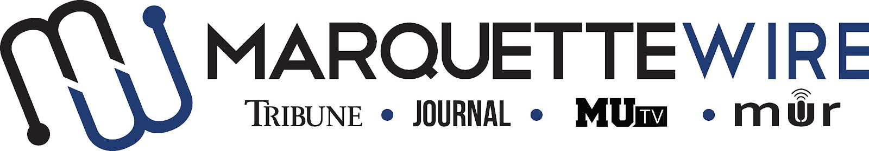
MARQUETTE WIRE ASSISTANT PROJECTS EDITOR APPLICATION

-Academic Year: 2022-23

-Deadline for all materials to be submitted is Sunday, May 22 at 11:59 p.m. CST.

-Applications should be emailed to incoming executive projects editor Skyler Chun at skyler.chun@marquette.edu.
-Once the application is turned in you will receive an email to schedule an interview. If off campus, virtual interviews can be arranged.

Materials to submit include:
- Attached form
- Résumé
- Typed responses to the questions below
- At least 3 writing and/or multimedia samples

Best of luck and thank you for your interest in Marquette Student Media

Assistant Projects Editor job description:

-The assistant projects editor is responsible for helping curate investigative stories, manage current series and edit with reporters for publication in the Marquette Journal, Marquette Tribune, MUTV, MU Radio and the Wire website.

-Should feel comfortable with AP style, content-editing and directing reporters.

-Attend weekly All Staff meetings on Tuesdays and Wire training week (typically the week before classes begin).

APPLICATION

NAME: ________________________________

POSITION SOUGHT: Assistant Projects Editor

ACADEMIC MAJOR: ____________________

MINOR: ________________________________

OVERALL GPA (Optional): _____ GPA IN MAJOR (Optional): _____

YEAR IN SCHOOL: _______________________

E-MAIL: _____________________________

PHONE: ____________________________

HOME ADDRESS: _______________________

CITY: ___________________________

STATE/ZIP: __________

QUESTIONS
(please answer succinctly)

1.)What work within student media has prepared you for this leadership role, and what do you want to accomplish if chosen?

2.) If you are a returning Wire staff member, please provide a critique of the desk you are applying for and assess the current structure of the desk.

3.) Explain your conflict-resolution style and how you would handle disputes at all levels of student media.

4.) What project ideas do you have for next year?

