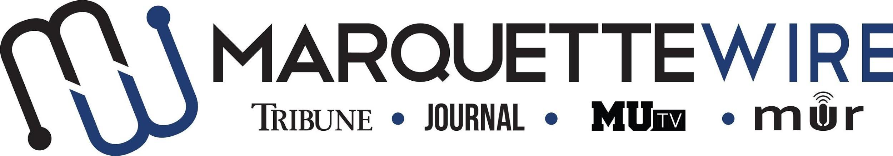

Application for Marquette University Television
Assistant Live Remote Coordinator

This position is to be served for both the fall and spring semesters. Please read the descriptions below for further information on job responsibilities.

The following materials are required for all applicants:

- Completed application
- Resume
- Any additional materials that you think would support your application (Portfolios, websites, videos, etc.)

Please send your completed application materials to MUTV General Manager Andrew Amouzou at andrew.amouzou@marquette.edu.

The deadline for all materials to be submitted by is Monday, May 24th at 5 p.m. CST.

Position Purpose:
The Assistant Live Remote Coordinator helps plan, coordinate, implement and execute studio and technical aspects of Marquette Wire live television remote broadcasts, including broadcasts of sporting events and other special live remote broadcasts done by student media. This position reports to the Live Remote Coordinator and MUTV General Manager.

Nature and Scope:
The Assistant Live Remote Coordinator is required to maintain consistent, productive and constructive communication with the Live Remote Coordinator and production department. She/he is expected to be knowledgeable about live remote equipment, live streaming technology, and basic troubleshooting. In conjunction with the Live Remote Coordinator, the assistant recruits/trains both volunteer and paid Wire staff for each live remote.

Specific job duties:
- Serves as staff for technical aspects of MUTV studio and live remote productions, which include weekly live news, sports, and entertainment programs.
- Assists in staffing live remote broadcasts
- Assists in studio and control room setup for each studio program, including erecting and lighting sets, setting up microphones, IFBs, iPads, and other duties as assigned by show rehearsal time.
- Maintains strong communication and establishes a collaborative work environment with the MUTV news, sports, and entertainment departments.
- Prepares volunteers for their assigned task by assisting in training them to operate the necessary technical equipment.
- Attends MUTV meetings, weekly news desk meetings, Wire all staff meetings and training week (typically the week before classes begin.)

MUTV Assistant Live Remote Coordinator Application

Name: ____________________________________________________

Position Sought: ____________________________________________

If you do not receive your first choice, would you be interested in a different position? (Note: Does not have to be in the same department).

Other Position Sought: _______________________________________

Academic Major: ___________________________________________

Minor: ____________________________________________________

Overall GPA (Optional): _____________ GPA in Major (Optional): _______________

Current Year in School: _____________________________________

Email: ___________________________________________________

Cell Phone: _______________________________________________

List of classes you have taken that apply to the position in which you are applying (For example: Digital media 2205): ______________________

__________________________________________________________

Please answer the following questions:

1. What is your experience with live remote broadcasts?

2. How would you improve live remotes for next year? How would you go about doing this?

3. How will you keep volunteers engaged and excited about MUTV so they keep coming back?

4. How do you handle stressful situations?

