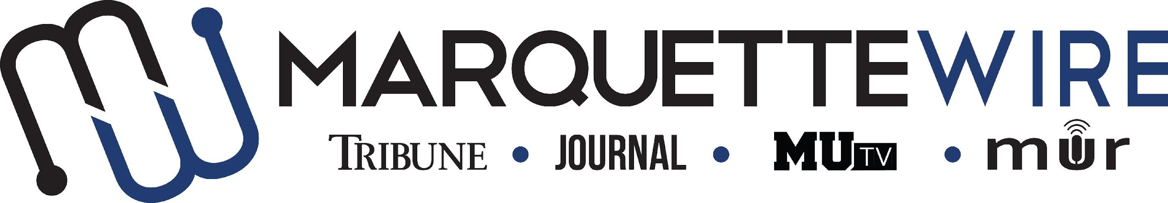

Application for Executive Photo Editor

Academic Year: 2021-22.
Deadline for all materials is 5 p.m. CST on Friday, April 16, 2021.
Applications should be emailed to incoming executive director Aimee Galaszewski at aimee.galaszewski@marquette.edu.

You will receive an email shortly after you apply regarding your interview time. If you are studying abroad or will not be on campus for the interview dates, a telephone or Skype interview can be arranged.

Materials to submit include:
- Attached form
- Résumé
- Typed responses to the questions below
- Writing and/or multimedia samples

Best of luck and thank you for your interest in Marquette student media.

Job description for Executive Photo Editor

Position Purpose:
The Photo Editor of the Marquette Wire oversees and coordinates all photographic content for the Marquette Wire. This position reports to the Managing Editor of the Tribune for related content, the Managing Editor of the Journal for related content, the General Manager of MUTV for related content and the General Manager of Marquette Radio for related content. The Photo Editor should be knowledgeable in Adobe Photoshop, and it is desirable for she/he to be knowledgeable in Adobe Illustrator and Lightroom. The Photo Editor is expected to communicate with the Social Media Editor to coordinate photographic posts on social media accounts. Reporting to the Photo Editor are the Photographers.

Nature and Scope:
The Photo Editor is expected to have extensive, superior knowledge of photography and DSLR cameras. She/he is responsible for holding weekly desk meetings, recruiting photography staff, interviewing and hiring Photographers and training photography staff and volunteers.

The Photo Editor is expected to create and maintain a professional, upbeat learning environment. She/he is expected to have superior organizational and communication skills and is responsible for conflict resolution within the photography desk.

The Photo Editor is required to oversee photographic content in the Marquette Tribune and Marquette Journal. The Photo Editor is expected to edit all photos for the Marquette Wire in Photoshop to ensure correct exposure and file type.

The Photo Editor is expected to upload, and help Photographers upload, all photos for stories to a Google Drive that is accessible to assistant editors, executive editors and managers. The Photo Editor is expected to enforce deadlines. The Photo Editor must also collect caption information for each photo taken, including names of people shown individually or in smaller groups. The Photo Editor is required to attend Wire all staff meetings and Wire student media training week (typically the week before classes begin).

The Photo Editor should have an eye for composition and aesthetics. The Photo Editor is expected to maintain a professional reputation in the community.

Specific job duties:

- Oversees all photography for the Wire.

- Schedules photographers for stories in the Marquette Tribune and Marquette Journal.

- Works closely with executive desk editors to coordinate photos for stories.

- Takes and edits photos for online and print stories.

- Helps to provide photo ideas to photographers for stories.

- Runs weekly desk meetings with photography staff to critique and improve photography.

- Attends weekly all staff meetings.

- Recruits, interviews and hires Photographers.

- Works closely with the managing editors of the Tribune and Journal to ensure exceptional photography, as well as proper captions and photo credits.

- Participates in weekly editorial board meeting to brainstorm for the weekly Wire editorial that appears in the Marquette Tribune.

- The Photo Editor is required to attend Wire student media training week (typically the week before classes begin).

- Knowledge of Adobe Photoshop is required. Knowledge of Adobe Illustrator and Lightroom is desirable.

Information for Executive Position, Marquette Wire

NAME: ________________________________________________

ACADEMIC MAJOR(S):______________________________________

MINOR(S): _________________________________________________

OVERALL GPA (Optional): _______________

YEAR IN SCHOOL: ________________________________________

EMAIL: _________________________________________________

PHONE: _________________________________________________

HOME ADDRESS: ________________________________________

CITY:____________________________________________________

STATE/ZIP: ______________________________________________

Application Questions for Executive Photo Editor:

1) What work within student media has prepared you for this leadership role, and what do want to accomplish if chosen?

2) Please provide a critique of the desk you are applying for and assess the current structure of the desk.

3) Explain your conflict-resolution style and how you would handle disputes at all levels of student media.

4) What about your desk would you like to change, or improve?

5) What makes you the best candidate for this job?

