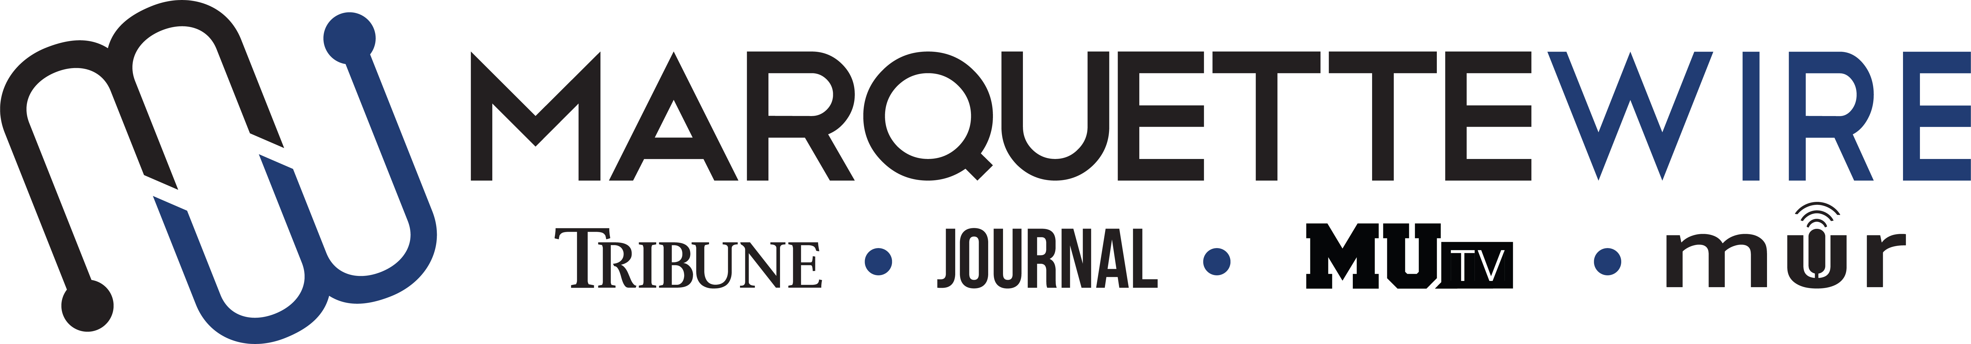

APPLICATION FOR
EXECUTIVE DIRECTOR OF THE MARQUETTE WIRE
ACADEMIC YEAR: 2021-2021

Position Description:
The executive director oversees all facets of the Marquette Wire, which includes the Marquettewire.org, the Marquette Tribune, the Marquette Journal, MUTV, MUR and all advertising and business operations.
The executive director works closely with the Director of Student Media on planning, budgets, training, critiques, workshops and other matters, and he or she collaborates with the other media leaders to coordinate content and workflow across the various student media platforms.
The executive director serves as the chief spokesperson for student media and as a liaison with other people and groups on campus, including the University Board for Student Media.
Some of the other duties of the position include overseeing all hiring and staff training, leading weekly all-staff meetings, resolving disputes at all levels of student media, and working with the other student media leaders and the Director of Student Media to establish goals and to develop and implement plans for the organization.
The deadline for submission of all materials is TUESDAY, FEB. 2 AT NOON. Late applications will not be accepted. Email applications to Dr. Erik Ugland, chair of the University Board for Student Media, at erik.ugland@marquette.edu. Please put your name and the position you are applying for in the subject line of your email.

The following materials are required for all applications:

- a completed application form,
- answers to the application questions,
- a resume,
- a cover letter to members of the Board for Student Media explaining why you are the best candidate for the position,
- additional materials that support of your qualifications for the position you are applying for (these can include letters of recommendation, portfolios, links to personal and/or professional web sites, PDFs, etc.)

In addition, you must be available to serve in this position for the summer, fall and spring semesters. Because of the time commitment required for the executive director position, concurrent internships are discouraged; however, an internship may be allowed if approved by the Director of Student Media and the chair of the University Board for Student Media.

It is recommended, but not required, that applicants have completed the college-required courses in media law and media ethics. It would also be wise to talk to the person currently holding the post to see whether or not it is a good fit for your personality and skill set.

Candidates will be interviewed by members of the Student Media Board. You will be contacted by Dr. Ugland regarding your interview time and date.

EXECUTIVE DIRECTOR APPLICATION

TOP THREE SKILLS YOU POSSESS FOR THIS POSITION:____________________

________________________________________________________________________

________________________________________________________________________

NAME: ________________________________________________________________

ACADEMIC MAJOR: ___________________________________________ _________
MINOR:___________________________________________

OVERALL GPA: ______________ GPA IN MAJOR: _____________

YEAR IN COLLEGE: _____________________

E-MAIL: ________________________________

CELL PHONE: ___________________________

Which of the following courses have you taken?

☐ Media Law (COMM 3800) ☐ Media Ethics (COMM or JOUR 3900)
☐ JOUR 2100 ☐ Intro Digital Media Production (DGMD 2205)
Other types of coursework that may be relevant to a specific position (beyond MU core):
Science breadth (e.g., physics/chem/bio/biomed/psych): __________________________
Business/Economics: ______________________________________________________
Computer Programming/Engineering: _________________________________________
Other (and why): _________________________________________________________

Please respond succinctly as possible to each of the following:

1) What work within student media has prepared you for this leadership role?

2) Describe your overall management style, how you handle interpersonal conflicts and how you motivate and support co-workers or others.

3) What is your overall vision for student media and what specific things would you hope to accomplish if chosen?

4) What strategies or steps do you think need to be taken (in terms of content or promotion) to make Marquette students more aware of student media and to keep them engaged throughout their time here?

What to Expect at the Student Media Interview

The interview will involve voting members of the Board for Student Media, which consists of representatives from the College of Communication, the College of Arts and Sciences, the Jesuit community, MUSG, the Graduate School and the Provost Office.

Relevant student media managers and advisers have the opportunity to offer feedback on the candidates to the board. However, they do not have a vote. There will be a discussion on the candidates and the board will vote, via a closed ballot. The individual who receives the majority of the votes will be awarded the position. Proxies will not be accepted. Each board member must be present to vote.

Students will be informed of the decision by Dr. Erik Ugland, chair of the Board for Student Media.

Tips:

It is likely that interviews will be conducted virtually, but you should still dress professionally. The board considers this a high profile, professional position so dress the part to the best of your ability.

You may want to have a copy of your application and resume handy so that you can reference them when board members ask questions.

