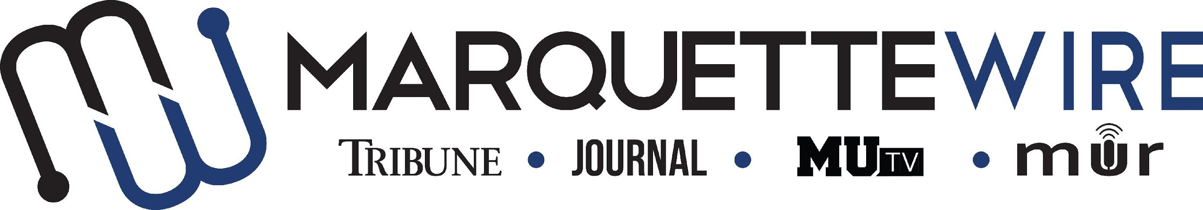

MARQUETTE WIRE PHOTOGRAPHER APPLICATION

-Academic Year: 2020-’21
-Applications should be emailed to Executive Photo Editor Zach Bukowski at zachary.bukowski@marquette.edu. Once the application is turned in you will receive an email to schedule an interview.

If you are not on campus, a Skype or phone interview will be arranged.

The application deadline is Friday, May 15, at noon CST. If openings remain after this date, application materials will be accepted on a rolling basis.

Materials to submit include:
- Attached form
- Résumé
- Typed responses to the questions below
- Up to five photography examples

PHOTOGRAPHER JOB DESCRIPTION

- Take assigned still photos across all desks of the Marquette Wire, including news, sports, A&E and opinions
- Edit all photos in Photoshop or other editing program to produce high-quality images
- Upload all photos to appropriate folders in Google Drive for Wire photo desk
- Meet weekly and semesterly deadlines for photos
- Communicate effectively with reporters to get photos for stories
- Reach out to sources for stories, or accompany reporters to events/interviews, to take assigned photos
- Work with executive editors and managers on vision for assigned photos
- Become familiar with Adobe Photoshop, Adobe Illustrator and potentially other Adobe design programs
- Become familiar with still photography equipment, particularly DSLR cameras
- Attend weekly desk meetings
- Attend weekly Wire all staff meeting
- Improve photographic skills each week

NAME:

ACADEMIC MAJOR(S):

MINOR (IF DECLARED):

OVERALL GPA (Optional):

GPA IN MAJOR (Optional):

YEAR IN SCHOOL:

E-MAIL:

PHONE:

CAMPUS ADDRESS:

CITY:

STATE/ZIP:

APPLICATION QUESTIONS

- What do you know about journalistic photography?

- How would you describe your photographic style, and what do you think goes into a good photo?

- What do you enjoy taking photos of the most?

- What skills make you a great fit for this role?

- Critique the current photographic content of the Marquette Wire.

