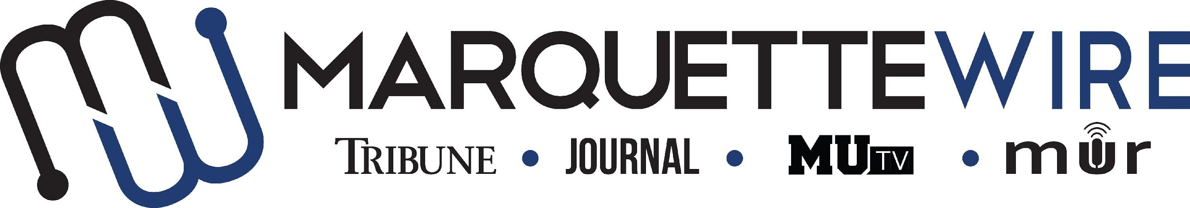

Application for Design Chief

Academic Year: 2020-21.
Deadline for all materials is noon CST on Friday, April 17, 2020.
Applications should be emailed to incoming executive director Natallie St. Onge at natallie.stonge@marquette.edu.

You will receive an email shortly after you apply regarding your interview time. If you are studying abroad or will not be on campus for the interview dates, a telephone or Skype interview can be arranged.

Materials to submit include:
- Attached form
- Résumé
- Typed responses to the questions below
- Writing and/or multimedia samples

Best of luck and thank you for your interest in Marquette student media.

Job description for Design Chief

Position Purpose:
The Design Chief of the Marquette Wire oversees and coordinates all design and graphic content for the Marquette Wire. This position reports to the Managing Editor of the Tribune for related content, the Managing Editor of the Journal for related content, the General Manager of MUTV for related content and the General Manager of Marquette Radio for related content. The Design Chief is expected to provide guidance and feedback to designers of each section. The Design Chief should be knowledgeable in Adobe InDesign, and it is desirable for she/he to be knowledgeable in Adobe Illustrator and Photoshop. The Design Chief is expected to communicate with the Social Media Editor to coordinate graphics and related posts on social media accounts. The Design Chief is also expected to serve as a consultant for in-house advertisements or flyers for the Marquette Wire. Reporting to the Design Chief are the Opinions Designer, A&E Designer and Sports Designer.

Nature and Scope:
The Design Chief is expected to have extensive, superior knowledge of design and graphics. She/he is responsible for holding weekly desk meetings, recruiting design staff, interviewing and hiring design staff in consultation with executive editors, training design staff and volunteers and overseeing all design and graphic content in the Tribune, Journal, MUTV and Marquette Radio.

The Design Chief is expected to create and maintain a professional, upbeat learning environment. She/he is expected to have superior organizational and communication skills and is responsible for conflict resolution within the design desk.

The Design Chief is required to oversee production of the design of the Marquette Tribune and Marquette Journal. The Design Chief is expected to assist in exporting the Tribune and Journal files before sending the files to printers. The Design Chief is expected to create or assist in creating graphics for the Marquette Tribune, the Marquette Journal, MUTV and Marquette Radio if needed. The Design Chief is required to attend Wire all staff meetings and Wire student media training week (typically the week before classes begin).

The Design Chief should be detail-oriented and precise in order to ensure clean design. The Design Chief is expected to maintain a professional reputation in the community.

Specific job duties:

- Oversees, leads and motivates the design staff in creating the weekly Tribune and the Journal at designated times throughout the semester.

- Consults on creative elements of the Wire and graphic design work for the Wire.

- Creates weekly schedules for designers.

- Works with desk executives on design for their respective sections.

- Designs the news section and front page of the Tribune.

- Designs the designated section of the Journal as assigned by the Journal managing editor.

- Runs weekly desk meetings with design staff to critique and improve design.

- Attends weekly all staff meetings.

- Attends weekly Late Night newspaper production sessions, as well as designated Journal production days.

- Recruits, interviews and hires the following desk staff: Arts & Entertainment Designer, Opinions Designer and Sports Designer. The Design Chief should consult executive editors when making hiring decisions for designers of each section.

- Participates in weekly editorial board meeting to brainstorm for the weekly Wire editorial that appears in the Marquette Tribune.

- The Design Chief is required to attend student media training week (typically the week before classes begin).

- Knowledge of Adobe InDesign is required. Knowledge of Adobe Illustrator and Photoshop is desirable.

Information for Executive Position, Marquette Wire

NAME: ________________________________________________

ACADEMIC MAJOR(S):______________________________________

MINOR(S): _________________________________________________

OVERALL GPA (Optional): _______________

YEAR IN SCHOOL: ________________________________________

EMAIL: _________________________________________________

PHONE: _________________________________________________

HOME ADDRESS: ________________________________________

CITY:____________________________________________________

STATE/ZIP: ______________________________________________

Application Questions for Design Chief:

1) What work within student media has prepared you for this leadership role, and what do want to accomplish if chosen?

2) Please provide a critique of the desk you are applying for and assess the current structure of the desk.

3) Explain your conflict-resolution style and how you would handle disputes at all levels of student media.

4) What about your desk would you like to change, or improve?

5) What makes you the best candidate for this job?

