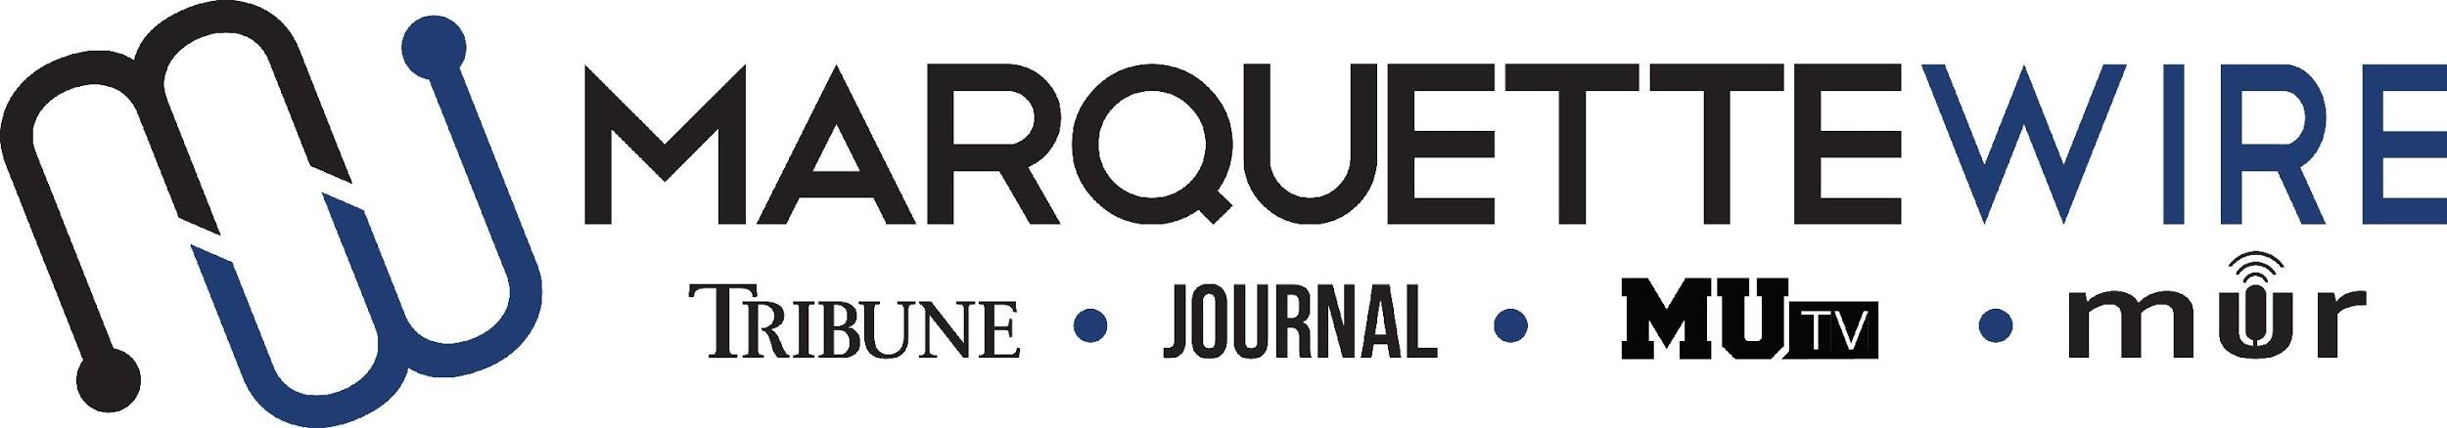

Democratic National Convention Application

This application is for Marquette University students who are interested in covering the 2020 Democratic National Convention in Milwaukee, Wisconsin, for student media. This includes coverage in the Marquette Tribune, MUTV and Marquette Radio.

Students will be expected to be on campus and available for coverage from Saturday, July 11, 2020, through Saturday, July 18, 2020. The DNC will take place from Monday, July 13, 2020, through Thursday, July 16, 2020.

Applications can be submitted via email to the Marquette Wire DNC Planning Committee at marquettewireDNC@gmail.com. The deadline for application materials is Friday, March 6, 2020, at 5 p.m. CST.

Questions can be directed to Marquette Wire executive director Sydney Czyzon at sydney.czyzon@marquette.edu.

The following materials are required to submit:
- Completed application
- Resume

A variety of roles will be available for students. This could include the following positions: Reporters, editors, designers, photojournalists, circulation staff, directors, technical directors, camera operators, producers, floor directors, video editors, anchors, podcast producers and more. The Marquette Wire DNC Planning Committee will gather available students and skill sets to determine which students will be assigned which roles.

This opportunity is not limited to people with experience in student media or the College of Communication. It is open to all who are interested.

GENERAL INFORMATION:

NAME:

EMAIL:

PHONE:

YEAR IN SCHOOL:

ACADEMIC MAJOR(S):

ACADEMIC MINOR(S):

OVERALL GPA:

HOME ADDRESS:

CITY:

STATE/ZIP:

EXPERIENCE INFORMATION:

INTERESTS (Any relevant interests that may apply to DNC coverage, such as a certain area of politics or journalism):

CLASSES (Any relevant classes that may apply to DNC coverage, such as journalism, digital media or political science courses, etc.):

SKILLS (Any relevant classes that may apply to DNC coverage, such as ability to use camera and radio equipment, etc.):

QUESTIONS:

- If you could choose, what position would you be interested in fulfilling for 2020 Democratic National Convention coverage (i.e. reporter, editor, producer, etc.)?

- What unique skills or perspective would you bring to the Marquette Wire’s coverage of the 2020 Democratic National Convention?

- What personal goals would you seek to accomplish through this experience?

AVAILABILITY:

Please mark an “X” for every date and time slot you would be available for DNC coverage:

 | Sat.  7/11 | Sun.  7/12 | Mon.  7/13 | Tues.  7/14 | Wed.  7/15 | Thurs.  7/16 | Fri.  7/17 | Sat.  7/18
8 a.m. - 12 p.m.
12 p.m. - 5 p.m.
5 p.m. - 11 p.m.

