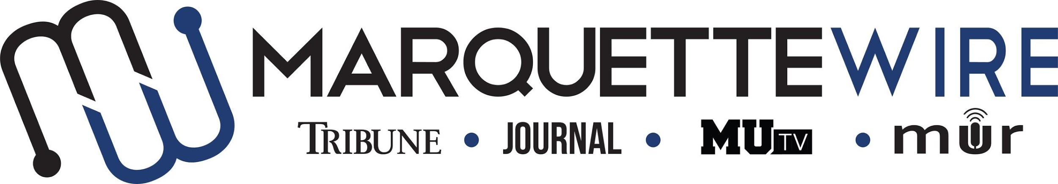

Application for Marquette University Radio
Audio Producer Positions

Thank you for your interest in applying. The audio producer positions available for the 2019-’20 school year include:

MUR Audio Producers
  - MUR Audio News Producer
  - MUR Audio Sports Producer (filled)
  - MUR Audio A&E Producer (filled)

These positions ideally are to be served in both the fall and spring semesters. Please read the descriptions below for further information on job responsibilities.

The following materials are required for all applicants:

- Completed application
- Cover letter
- Resume
- Any additional materials that you think would support your application (Portfolios, audio pieces, stories, etc.)

Please send your completed application materials to MUR general manager Mackane Vogel at mackane.vogel@marquette.edu. You will then receive an email to set up an interview.

The application deadline is Sunday, December 1, 2019, at noon.

Position Descriptions

MUR Audio News Producer

Position Purpose:
The MUR Audio News Producer plans, coordinates and creates the weekly MUR newscast. The Audio News Producer also works closely with news reporters to create podcasts and other audio content for the news section of the Marquette Wire. This person is expected to provide training and guidance to news reporters who wish to become more familiar with audio storytelling.

This position reports to the Marquette Wire Executive News Editor as well as the MUR General Manager.

Nature and Scope:
The MUR Audio News Producer works closely with the Marquette Wire Executive News Editor to plan and execute weekly audio news content for the Marquette Wire based off the budget created by the Wire Executive News Editor. She/he is required to maintain strong communication with news reporters and the Executive News Editor, and is expected to create and maintain a professional, upbeat learning environment. The MUR Audio News Producer is expected to plan and execute a weekly MUR radio newscast.

The MUR Audio News Producer must be proficient in Adobe Audition. It is preferable that the MUR Audio News Producer is familiar with the MUR radio studio equipment, as well as other recording equipment.

The MUR Audio News Producer is expected to attend Wire all staff meetings, designated MUR meetings, and weekly news desk budget meetings, as well as attend student media training week (typically the week before classes begin).

MUR Audio Sports Producer

Position Purpose:
The MUR Audio Sports Producer plans, coordinates and creates the weekly MUR sportscast. The Audio News Producer also works closely with sports reporters to create podcasts and other audio content for the sports section of the Marquette Wire. This person is expected to provide training and guidance to sports reporters who wish to become more familiar with audio storytelling. This person also works closely with the Executive Sports Editor to plan and help execute MUR live broadcasts when needed.

This position reports to the Marquette Wire Executive Sports Editor as well as the MUR General Manager.

Nature and Scope:
The MUR Audio Sports Producer works closely with the Marquette Wire Executive Sports Editor to plan and execute weekly audio sports content for the Marquette Wire based off the budget created by the Wire Executive Sports Editor. She/he is required to maintain strong communication with sports reporters and the Executive Sports Editor, and is expected to create and maintain a professional, upbeat learning environment. The MUR Audio Sports Producer is expected to plan and execute a weekly MUR radio sportscast.

The MUR Audio Sports Producer must be proficient in Adobe Audition. It is preferable that the MUR Audio Sports Producer is familiar with the MUR radio studio equipment, as well as other recording equipment.

The MUR Audio Sports Producer is expected to attend Wire all staff meetings, designated MUR meetings, and weekly sports desk budget meetings, as well as attend student media training week (typically the week before classes begin).

MUR Audio A&E Producer

Position Purpose:
The MUR Audio A&E Producer plans, coordinates and creates a weekly MUR segment for the A&E section of the Marquette Wire. The Audio News Producer also works closely with A&E reporters to create podcasts and other audio content for the A&E section of the Marquette Wire. This person is expected to provide training and guidance to A&E reporters who wish to become more familiar with audio storytelling.

This position reports to the Marquette Wire Executive A&E Editor as well as the MUR General Manager.

Nature and Scope:
The MUR Audio A&E Producer works closely with the Marquette Wire Executive A&E Editor to plan and execute weekly audio A&E content for the Marquette Wire based off the budget created by the Wire Executive A&E Editor. She/he is required to maintain strong communication with A&E reporters and the Executive A&E Editor, and is expected to create and maintain a professional, upbeat learning environment. The MUR Audio A&E Producer is expected to plan and execute a weekly MUR segment for the A&E desk.

The MUR Audio A&E Producer must be proficient in Adobe Audition. It is preferable that the MUR Audio A&E Producer is familiar with the MUR radio studio equipment, as well as other recording equipment.

The MUR Audio A&E Producer is expected to attend Wire all staff meetings, designated MUR meetings, and weekly A&E desk budget meetings, as well as attend student media training week (typically the week before classes begin).

MUR Staff Application

Name: ____________________________________________________

Position Sought: ____________________________________________

If you do not receive your first choice, would you be interested in a different position? (Note: Does not have to be in the same department).

Other Position Sought: _______________________________________

Academic Major: ___________________________________________

Minor: ____________________________________________________

Overall GPA: _____________ GPA in Major: _______________

Current Year in School: _____________________________________

Email: ___________________________________________________

Cell Phone: _______________________________________________

List of classes you have taken that apply to the position in which you are applying (For example: Digital media 2205): ______________________

__________________________________________________________

Please answer the following questions:

1. Why do you think audio content is important?

2. What goes into a successful audio story for your desk?

3. Pitch an audio story for your desk.

4. What vision do you have for the weekly segment for your desk?

5. How would you help train other staff members who are interested in learning about audio storytelling?

