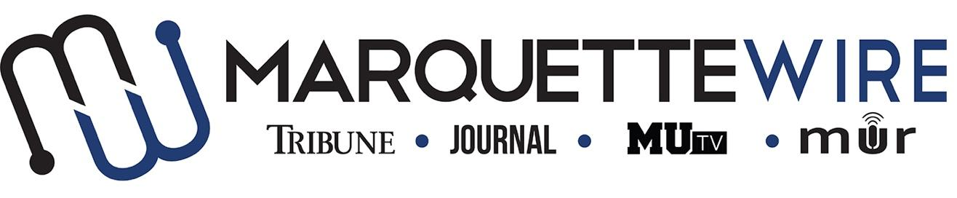
PUBLICIST/ASSISTANT PUBLICIST APPLICATION

Academic Year: 2019-’20.
Deadline: Sunday, May 12, 2019 at noon.

Please email your application materials to General Manager Mackane Vogel (mackane.vogel@marquette.edu).

If off campus, all interviews will be conducted by Skype, Facetime, or telephone.

Thank you for your interest in Marquette student media.

Job Descriptions
Publicist
- Coordinates annual events such as the Rock-a-Thon and Spring Concert with Wire Events staff.
- Responsible for updating all social media outlets for Marquette Radio’s page (Facebook, Twitter, Instagram) of news, promos, events, etc., but also give Marquette Wire’s social media coordinator Marquette Radio content to post.
- Orders and tracks inventory of promotional items
- Works with other directors to see their department's’ needs are met
- Helps GM/PD and all Wire staff in coming up with new events to get Radio involved around campus (college radio day, student showcases at the brew, etc.)
- In charge of organizing and hosting “Promo Friday’s” with the other Wire mediums.
- Reach out to musicians and concert venues to help set up interviews and giveaways for music department.
- Reach out to other clubs, organizations and local places to help find opportunities for DJ’s to play music for events.
Assistant Publicist
- Assists Event Coordinator in planning annual events and staying organized
- Assists in posting on social media
- Works with DJs to distribute incoming promotional material
- Assists in scheduling interviews and DJ opportunities.

PUBLICIST POSITIONS, MARQUETTE WIRE

NAME: ________________________________________________
POSITION APPLYING FOR: ______________________________
ACADEMIC MAJOR:______________________________________
MINOR: _________________________________________________
OVERALL GPA: _____________GPA IN MAJOR: ______________
YEAR IN SCHOOL________________________________________
E-MAIL: _________________________________________________
PHONE: _________________________________________________
HOME ADDRESS: ________________________________________
CITY:____________________________________________________
STATE/ZIP: ______________________________________________

Application Questions

1.) What unique ideas do you have to promote Marquette Radio’s various events?

2.) What do you think Marquette Radio needs to improve on?

3.) How would you promote Marquette Radio on social media and across campus?

3.) What are your event ideas, training ideas, or ideas for ways DJs could bond?

