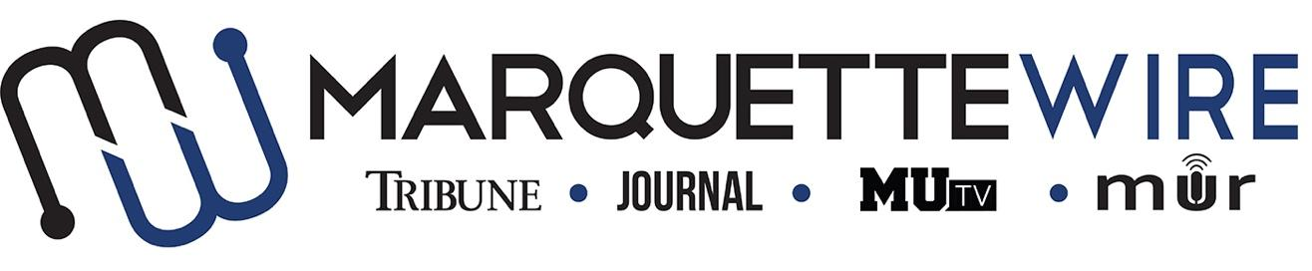
AUDIO CONTENT DIRECTOR APPLICATION

Academic Year: 2019-’20.
Deadline: Sunday, May 12, 2019 at noon.

Please email your application materials to incoming General Manager Mackane Vogel (mackane.vogel@marquette.edu).

If off campus, all interviews will be conducted by Skype, Facetime, or telephone.

Thank you for your interest in Marquette student media.

Job Description
Audio Content Director
- Assisting in editing audio interviews/podcasts for other parts of the Wire staff
- Talking to the different Wire Execs to make sure they have podcasts going out weekly
- Coordinate with Wire Execs to help make sure reporters are adding audio to their stories and creating multimedia pieces.
- Produce a creative audio piece each week that is outside the music realm.
- Help create sweepers for DJ shows, events on campus and other Wire departments to be played by the DJs.
- Assist projects desk in developing a possible long-term audio story.

AUDIO CONTENT DIRECTOR, MARQUETTE WIRE

NAME: ________________________________________________
POSITION APPLYING FOR: ______________________________
ACADEMIC MAJOR:______________________________________
MINOR: _________________________________________________
OVERALL GPA: _____________GPA IN MAJOR: ______________
YEAR IN SCHOOL________________________________________
E-MAIL: _________________________________________________
PHONE: _________________________________________________
HOME ADDRESS: ________________________________________
CITY:____________________________________________________
STATE/ZIP: ______________________________________________

Application Questions

1.) How will you effectively coordinate audio content among the various desks in the Marquette Wire?

2.) Pitch a weekly creative audio piece.

3.) How would you work with the projects desk to create long-form podcast content?

4.) What do you think goes into a successful podcast?

