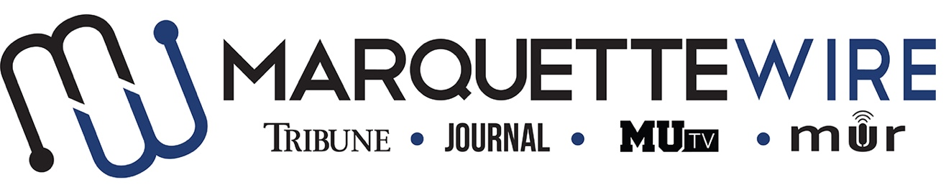
MUSIC DIRECTOR/ASSISTANT MUSIC DIRECTOR APPLICATION
Academic Year: 2018-2019.
Deadline: Friday May 11, 2018 at noon.
In addition to answering the questions below, please email your resumé and all other relevant materials to General Manager Gabby Powell (gabrielle.marx@marquette.edu) and Assistant General Manager Nick Cordonnier (nicholas.cordonnier@marquette.edu).
All interviews will be conducted by Skype, Facetime, or telephone. Please indicate which you would prefer in your email. Thank you, and good luck.
Job Descriptions
Music Director
- Promotes newly received music and shares it with DJs
- Builds and maintains a relationship with promoters
- Working with other Wire mediums to make sure multimedia content is being posted.
- Writing up concert and album reviews for the Wire.
- Works closely with Wire A&E Executive to coordinate content
- Tracks weekly music being played by DJs
- Reviews new CDs and puts them into rotation
- Conducting interviews with artists through video and/or audio
- Assists with the Spring Concert/Rock-a-Thon Showcase/music related events
- Hosts weekly “New Music Monday” program

Music Assistant (2 positions available)
- Reviews CDs for required tracks playlist
- Helps with tracking if Music Director needs
- Assists in interviews with musical artists
- Co-hosts New Music Monday
Application
Name:
Position being applied for:
Year in School:
Phone number:

Application Questions
1.) What do you like about Marquette Radio?
2.) What do you think Marquette Radio needs to improve on?

3.) If you were on staff, what are some things you would like the station to do? Any event ideas, training ideas, or ideas for ways DJs could bond?

