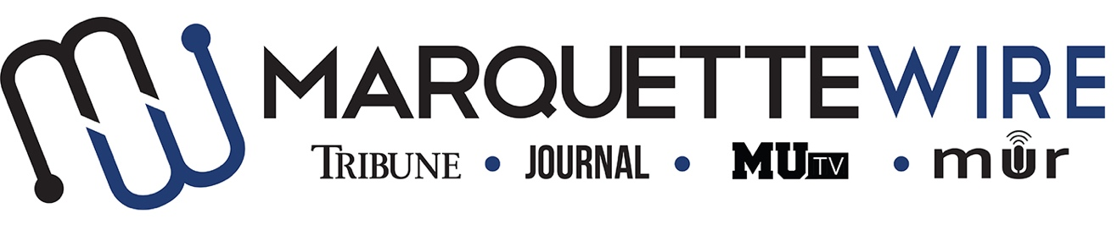
AUDIO CONTENT DIRECTOR APPLICATION
Academic Year: 2018-2019.
Deadline: Friday May 11, 2018 at noon.
In addition to answering the questions below, please email your resumé and all other relevant materials to General Manager Gabby Powell (gabrielle.marx@marquette.edu) and Assistant General Manager Nick Cordonnier (nicholas.cordonnier@marquette.edu).
All interviews will be conducted by Skype, Facetime, or telephone. Please indicate which you would prefer in your email. Thank you, and good luck.

Job Description
Audio Content Director
- Assisting in editing audio interviews/podcasts for other parts of the Wire staff
- Talking to the different Wire Execs to make sure they have podcasts going out weekly
- Coordinate with Wire Execs to help make sure reporters are adding audio to their stories and creating multimedia pieces.
- Produce a creative audio piece each week that is outside the music realm.
- Help create sweepers for DJ shows, events on campus and other Wire departments to be played by the DJs.
- Assist projects desk in developing a possible long-term audio story.

Application
Name:
Position being applied for:
Year in School:
Phone number:

Application Questions
1.) What do you like about Marquette Radio?
2.) What do you think Marquette Radio needs to improve on?

3.) If you were on staff, what are some things you would like the station to do? Any event ideas, training ideas, or ideas for ways DJs could bond?

