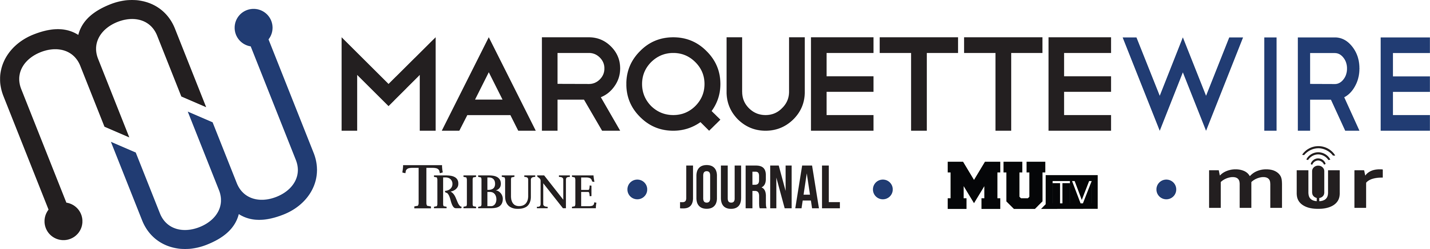
APPLICATION FOR MARQUETTE WIRE ASSISTANT PROJECTS EDITOR
Academic Year: 2018-2019.
Deadline for all materials is noon Friday, April 20.
Applications should be emailed to incoming executive projects editor Morgan Hughes at morgan.hughes@marquette.edu
You will receive an email shortly after you apply regarding your interview time. If you are studying abroad, a telephone or Skype interview can be arranged.
Materials to submit by Friday, April 20 include:
- Attached form
- Résumé
- Typed responses to the questions below
- Writing and/or multimedia samples
Best of luck and thank you for your interest in Marquette Student Media.

Assistant Projects Editor of the Marquette Wire job description:
The assistant projects editor is responsible for helping curate investigative stories, manage current series and edit with reporters for publication in the Marquette Journal, Marquette Tribune, MUTV, MU Radio and the Wire website.
Will likely be considered as the Projects Editor for Spring 2019.
Should feel comfortable with AP style, content-editing and directing reporters.

Assistant Projects Editor Application
NAME: _________________________________________________________
POSITION APPLYING FOR: _______________________________________
ACADEMIC MAJOR:_____________________________________________
MINOR: ________________________________________________________
OVERALL GPA: _____________GPA IN MAJOR: ______________
YEAR IN SCHOOL_______________________________________________
E-MAIL: _______________________________________________________
PHONE: _______________________________________________________
HOME ADDRESS: ______________________________________________
CITY:_________________________________________________________
STATE/ZIP: ___________________________________________________

Questions
- What work within student media has prepared you for this leadership role, and what do want to accomplish if chosen?

- Are you interested in being considered for the projects editor position Spring 2019?

2.) Please provide a critique of the desk you are applying for and assess the current structure of the desk.

3.) Explain your conflict-resolution style and how you would handle disputes at all levels of student media.

4.) What project ideas do you have for next year?

5.) What makes you the best candidate for this job?

